LIBERTY REGIONAL WASTE DISTRICT BOARD MEETING MINUTES
JUNE 20, 2019

The LRWD board meeting was called to order by President Steve Knote@ 7:00 p.m. Members in attendance were: Brent Devine, Steve Graves, Steve Knote, Bruce Reinke and Adam Sewell.

Others in attendance were: Office Manager Kathy May, Bookkeeper Peg Selvey, Attorney Mark Abrell, Engineer Rick Miller, Joe Alberson, Tim Maddy and Brad Marshall. Superintendent Jerry Zearbaugh was on vacation.
Mr. Knote opened the floor for new business. New Business:
Mr. Knote recognized Timothy Maddy. Mr. Maddy told the Board that he had inherited
his aunt's house at 808 S Winmere Ave. He is going to remodel the house to make it livable. He asked the Board if they would waive the monthly bill until he finished with the remodeling. He hoped to be done by August. The Board told him if it takes longer than August, come back to a meeting and they will consider his request.

Also, there is a past due balance on the house, that Mr. Maddy isn't responsible for and his Aunt is deceased. The house has been empty for several years.
There is $1135.91 owed on the property. Mr. Maddy took possession 11-9-18, so he will owe starting with that date.
Mr. Graves made a motion to write off $1135.91 as a bad debt. Mr. Sewell seconded the motion, all ayes, no nays, motion carried.

Mr. Knote recognized Joe Alberson, representing the Selma Little League ball diamond. Mr. Alberson said they have had a bad leak at the concession stand. They have had the Water Company out, but they said the ball diamond needed to have a plumber come to check things out. Mr. Alberson will come back to a meeting after the plumber checks things out.

Mr. Devine made a motion to accept the minutes as written from last month's meeting. Mr. Sewell seconded the motion, all ayes, no nays, motion carried.

Claims totaling $207,703.69 were viewed and signed.

Mr. Sewell made a motion to accept the claims as written. Mr. Reinke seconded the motion, all ayes, no nays, motion carried.

2

Mr. Knote recognized Peg Selvey, Bookkeeper, for the financial report. Peg reported receipts for May 2019 were $129,628.23 with disbursements of$155,066.91 leaving
$25,438.68 in the red.

As of today, 6-20-19 the billing office has collected $104,271.10 plus a direct deposit from Delaware County Treasurer for liens they collected in the amount of $11,337.72 making $115,608.82 with disbursements of$163,922.60 leaving $48,313.78 in the red. The Muncie Sanitary bill is included in this in the amount of $110,967.09 for June 2019. The next bill will be $71,266.91 for July.

The year to date is $770,172.76 with disbursements of $830,549.23, leaving $60,376.47 in the red.

Mr. Devine made a motion to approve the financial report. Mr. Reinke seconded the motion, all ayes, no nays, motion carried. .

Peg gave the members a copy of the minutes from the special joint meeting with Delaware Regional Waste District that was held 6-11-19 at Selma Elementary.
Mr. Sewell made a motion to accept the minutes as written. Mr. Reinke seconded the motion, all ayes, no nays, motion carried.

Peg told the Board that the bond is due in June and we only pay the interest in June and in December we pay the principal plus the interest. The interest in June is $45,433.70.

Mr. Knote recognized Attorney Mark Abrell. Mark told the Board that he had the amended copy of the shut-off Ordinance 2019-4 and is ready for introduction and adoption.
Mr. Devine made a motion to adopt Ordinance 2019-4 for shut-off of non-paying customers. Mr. Sewell seconded the motion, all ayes, no nays, motion carried.

Mark said Forrest Storms had called him about the poor drainage on his property since we installed the fence around our lift-station.
Mark said we have some responsibility to improve drainage.
Engineer Rick Miller said we might be able to put some stone down to make it drain better.

Mark told the Board that July 10th has been set for mediation hearings.

Mark talked to the Board about the response to Delaware Regional inter-local agreement. After much discussion among members, they said it should be 50-50% in capital assets only. Each entity would be 50-50. If capacity is exceeded on a regular basis then that entity would pay more for treatment. Mark said the vote should be unanimous with the members.

Mr. Graves made a motion for a proposed Amendment #1 to the current Inter-local Agreement between LRWD & DCRWD Board of Trustees to enter into an agreement

3

with Commonwealth Engineering along with DCRWD and making LRWD a party to the existing agreement with Commonwealth along with DCRWD and making LRWD responsible for 50% of Commonwealth's charges, including all charges to date regarding the joint treatment plant project. LRWD shall also pay for 50% of the accounting costs associated with any reports or calculations required to obtain financing for the total project. Also, LRWD shall approve the PER subject to the provisions in Amendment #1.

The motion was seconded by, Mr. Devine, Mr. Graves, Mr. Knote, Mr. Reinke and Mr. Sewell, no nays, motion carried.

Mr. Knote recognized Engineer Rick Miller. Rick didn't have anything to discuss except he said we could possibly add gravel around the Whitney Rd lift station to divert the water away from Mr. Storms’ property.
Mr. Knote recognized Superintendent Jerry Zearbaugh. Jerry was on vacation.
Mr. Knote recognized Office Manager Kathy May. Kathy told the Board that Jill Kinder still hasn't paid this month either.

Kathy presented Board members with a copy of the current trial balance.

Kathy reported to the Board that we received the lien money from Delaware County Treasurer by direct deposit in the amount of $11,337.72.
Kathy asked the Board if we could write off some accounts as bad debts that we will never collect due to bankruptcy, sheriffs’ sales or tax sales.

Mr. Devine made a motion to write-off$597.76 for property located at 12100 E Jackson St. that sold to Andre & Krystal Burton. Mr. Graves seconded the motion, all ayes, no nays, motion carried.

Kathy had four (4) other properties that also need written off.
1. $2616.52 | 9805 E Miller St. House is being tom down. Donna Hunt
2. 829.90 | 10208 E Muncie St Bankruptcy filed in 2017 Gretchen Bales
3. 3285.18 | 7901 E Gloucester Rd Capped off in 2012 Marty Cordle
4. 1108.28 | 8009 E Gloucester Rd Trailer moved out. James Stevens
$7839.88 | Total amount to be written off

Mr. Graves made a motion to write off these four (4) properties for reasons stated in the amount of $7839.88. Mr. Devine seconded the motion, all ayes, no nays, motion carried.
Mr. Knote seeing no further business adjourned the meeting. Liberty Regional Waste District
Kathy May I Office Manager
June 20, 2019
Meeting adjourned @ 9:21 p.m.

.I

ORDINANCE NO. 2019- -
!.
AN ORDINANCE TO ESTABLISH A POLICY FOR THE USE OF "SHUT OFF VALVES" BY THE LIBERTY REGIONAL WASTE DISTRICT AND THE ASSOCIATED COSTS OF INSTALLATION OF SUCH VALVES AND ALSO UPDATING THE TAP FEES CHARGED TO CONNECT TO THE SYSTEM
WHEREAS, the Board of Trustees of the Liberty Regional Waste District (LRWD) is aware that pursuant to IC 13-26-5-2(10), LRWD may "[ r]efuse the services of the district's facilities if the rates or other charges are not paid by the user." ; and

WHEREAS, the Board. of Trustees of the Liberty Regional Waste District is also aware that certain mechanical "shut off valves" exist that, if available and installed at a particular property, may more economically allow LR.WD to refuse service to a user who fails and/or refuses to pay the lawful charges for LRWD's sewage service; and
. . .

WHEREAS, the Liberty Regional Waste District desires to establish a policy for the use of such "shut
off valves" on the connections of properties where the user has failed and/or refused to pay for the lawful charges for sewage service or ancillary services provided by LRWD; and
WHEREAS, LRWD also desires to update the tap in fee for customers connecting to the LRWD sewage collection system.
Now therefore, be it ordained by the Board of Trustees of the Liberty Regional Waste District, Indiana, that:
SECTION 1. In the event that charges associated with providing sewer service or ancillary services to a particular parcel of prope11y which is connected to the LRWD sewage collection system remain unpaid after 30 days’ notice to the owner of the property, the LRWD shall issue a Disconnection Notice to the owner of the property mailed by regular mail to address used to send property tax bills by Delaware County for the associated prope11y AND delivered or posted to the property in question. Said Disconnection Notice shall state the amounts which are owed as of the date of the Notice and shall indicate that if said amounts are not paid in full or payment arrangements acceptable to LRWD are not made within 10 days from the date of the Notice that LRWD shall refuse to provide further sewage service and shall proceed with disconnecting or interrupting sewage service to the property in question. In addition, said Notice shall also indicate that the owner(s) of the property shall be responsible for reimbursing LRWD for the costs of disconnecting or interrupting sewage service to the property. Once the contractor, if utilized, or the excavation has been scheduled the process will be completed regardless of whether the customer pays off the billing amount in full (unless the parties agree otherwise).
SECTION 2. In the event that LRWD endeavors to refuse service to a property due to non-payment of the lawful charges associated with providing sewage service to such property, then the owner(s) of such property shall be responsible for reimbursing LRWD for the costs associated with disconnecting or interrupting the sewage service to said property. There will be a minimum fee of $100.00.
SECTION 3. In the event that the owner(s) of a property wishes to re-connect to the LRWD sewage collection system after LRWD has disconnected service to the property, said owner(s) shall be required to pay any charges and or costs due and owning by such owner before service may be resumed. In addition, the owner(s) of said property shall also be required to pay a deposit equal to 6 months of the average bill for the property before service may be resumed. If after service is resumed, the charges associated providing sewage service are paid in a timely manner for 12 months, then the deposit shall be returned to the owner(s).

SECTION 4. If ownership of a property, which has service disconnected, changes re-connection of service shall require the payment of a "Tap Fee" in the amount of $600.00. Commercial customers shall have a "Tap Fee" in the amount of$1500.00.
SECTION 5. Anyone who tampers with a ''shut off valve" installed by LRWD or its agents shall be fined a maximum of $1500.00 for each incident of tampering. Tampering for the purpose of this Ordinance means taking any unauthorized action to open a "shut off valve" to allow the property to connect to LRWD's sewage collection system.

This ordinance shall be in full force and effect after its passage and signing by the Board of Trustees.

LIBERTY REGIONAL WASTE DISTRICT

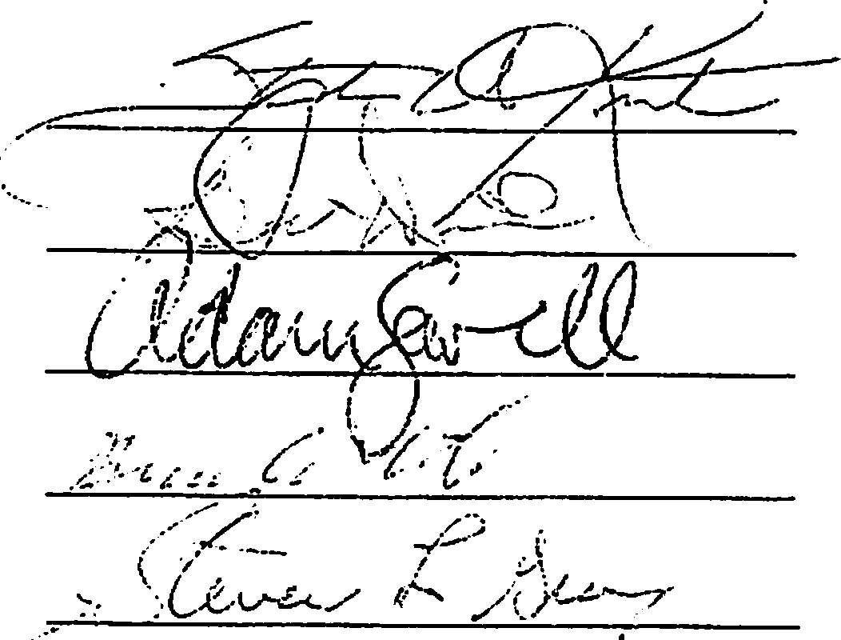
Adopted thi ay of {..11..k' > -" , 2019

