ORDINANCE NO. 2019-4
AN ORDINANCE TO ESTABLISH A POLICY FOR THE USE OF "SHUT OFF VALVES" BY THE LIBERTY REGIONAL WASTE DISTRICT AND THE ASSOCIATED COSTS OF INSTALLATION OF SUCH VALVES AND ALSO UPDATING THE TAP FEES CHARGED TO CONNECT TO THE SYSTEM
WHEREAS, the Board of Trustees of the Liberty Regional Waste District (LRWD) is aware that pursuant to IC 13-26-5-2(10), LRWD may "refuse the services of the district's facilities if the rates or other charges are not paid by the user." ; and
WHEREAS, the Board of Trustees of the Liberty Regional Waste District is also aware that certain mechanical "shut off valves" exist that, if available and installed at a particular property, may more economically allow LRWD to refuse service to a user who fails and/or refuses to pay the lawful
charges for LRWD's sewage service; and
. . .
WHEREAS, the Liberty Regional Waste District desires to establish a policy for the use of such "shut
off valves" on the connections of properties where the user has failed and/or refused to pay for the lawful charges for sewage service or ancillary services provided by LRWD; and
WHEREAS, LRWD also desires to update the tap in fee for customers connecting to the LRWD sewage collection system.
Now therefore, be it ordained by the Board of Trustees of the Liberty Regional Waste District, Indiana, that:
SECTION 1. In the event that charges associated with providing sewer service or ancillary services to a particular parcel of prope11y which is connected to the LRWD sewage collection system remain unpaid after 30 days’ notice to the owner of the property, the LRWD shall issue a Disconnection Notice to the owner of the prope11y mailed by regular mail to address used to send property tax bills by Delaware County for the associated prope11y AND delivered or posted to the property in question. Said Disconnection Notice shall state the amounts which are owed as of the date of the Notice and shall indicate that if said amounts are not paid in full or payment arrangements acceptable to LRWD are not made within 10 days from the date of the Notice that LRWD shall refuse to provide further sewage service and shall proceed with disconnecting or interrupting sewage service to the property in question. In addition, said Notice shall also indicate that the owner(s) of the property shall be responsible for reimbursing LR.WO for the costs; of disconnecting or interrupting sewage service to the property. Once the contractor, if utilized, or the excavation has been scheduled the process will be completed regardless of whether the customer pays off the billing amount in full (unless the parties agree otherwise).
SECTION 2. In the event that LRWD endeavors to refuse service to a property due to non-payment of the lawful charges associated with providing sewage service to such property, then the owner(s) of such property shall be responsible for reimbursing LRWD for the costs associated with disconnecting or interrupting the sewage service to said property. There will be a minimum fee of $100.00.
SECTION 3. In the event that the owner(s) of a property wishes to re-connect to the LRWD sewage collection system after LRWD has disconnected service to the property, said owner(s) shall be required to pay any charges and or costs due and owning by such owner before service may be resumed. In addition, the owner(s) of said property shall also be required to pay a deposit equal to 6 months of the average bill for the property before service may be resumed. If after service is resumed, the charges associated providing sewage service are paid in a timely manner for 12 months, then the deposit shall be returned to the owner(s).

SECTION 4. If ownership of a property, which has service disconnected, changes re-connection of service shall require the payment of a "Tap Fee" in the amount of $600.00. Commercial customers shall have a "Tap Fee" in the amount of $1500.00.
SECTION 5. Anyone who tampers with a "shut off valve" installed by LRWD or its agents shall be fined a maximum of $1500.00 for each incident of tampering. Tampering for the purpose of this Ordinance means taking any unauthorized action to open a "shut off valve" to allow the property to connect to LRWD's sewage co11ection system.

This ordinance shall be in full force and effect after its passage and signing by the Board of Trustees.

LIBERTY REGIONAL WASTE DISTRICT

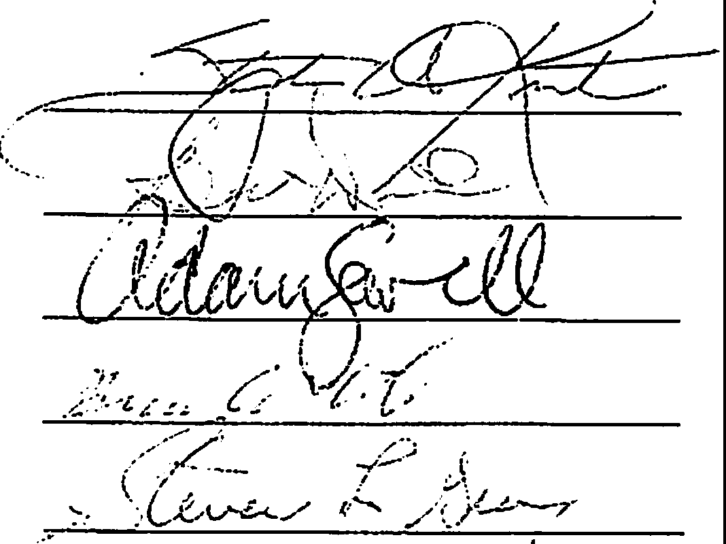
.Adopted this 20th of June 2019

